MINI PROJECT

INTERNET OF THINK (IOT) CASE STUDY ON IoT Security Challenges

Submitted by : Tanu Gajanan Kalambe

Submitted to : CodeAlpha

Academic Year : 2025-26

Introduction
The Internet of Things (IoT) connects billions of devices over the internet. These devices collect, exchange, and process data to improve automation, efficiency, and decision-making across homes, healthcare, industries, and transportation. Despite these benefits, IoT devices face serious cybersecurity risks because they are always connected and often have limited computing resources. As IoT adoption increases, securing these devices has become one of the most important challenges for businesses and governments. The Internet of Things (IoT) connects billions of devices over the internet. These devices collect, exchange, and process data to improve automation, efficiency, and decision-making across homes, healthcare, industries, and transportation. Despite these benefits, IoT devices face serious cybersecurity risks because they are always connected and often have limited computing resources. As IoT adoption increases, securing these devices has become one of the most important challenges for businesses and governments. 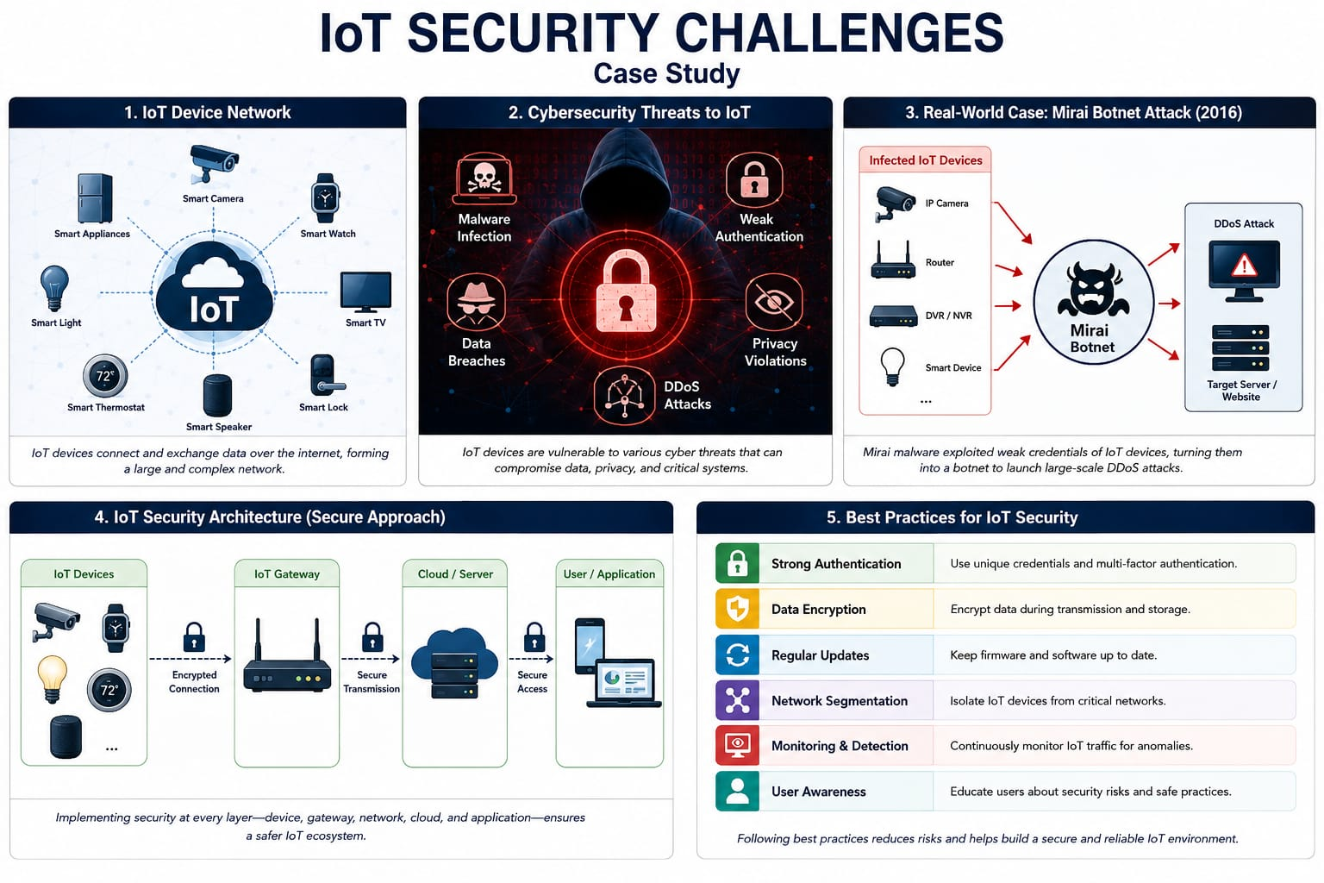 Figure no 1: SECURITY CHALLENGES:-
Figure no:- Overview of IOT devices and cybersecurity.

Background
Many IoT devices are designed with limited memory and processing power. Manufacturers often prioritize low cost and quick deployment over strong security. Common weaknesses include default passwords, outdated firmware, weak encryption, and insecure communication protocols. These weaknesses make IoT devices attractive targets for cybercriminals.Many IoT devices are designed with limited memory and processing power. Manufacturers often prioritize low cost and quick deployment over strong security. Common weaknesses include default passwords, outdated firmware, weak encryption, and insecure communication protocols. These weaknesses make IoT devices attractive targets for cybercriminals.

Major Security Challenges
1.Weak authentication allows attackers to access devices using default credentials. 2. Data privacy issues arise because IoT devices collect sensitive information. 3. Malware and botnet attacks compromise thousands of devices. 4. Lack of software updates leaves vulnerabilities unpatched. 5. Insecure communication enables data interception. 6. Physical tampering can expose stored data and device controls. 1. Weak authentication allows attackers to access devices using default credential. 2. Data privacy issues arise because IoT devices collect sensitive information. 3. Malware and botnet attacks compromise thousands of devices. 4. Lack of software updates leaves vulnerabilities unpatched. 5. Insecure communication enables data interception. 6. Physical tampering can expose stored data and device controls. 1. Weak authentication allows attackers to access devices using default credentials. 2. Data privacy issues arise because IoT devices collect sensitive information. 3. Malware and botnet attacks compromise thousands of devices. 4. Lack of software updates leaves vulnerabilities unpatched. 5. Insecure communication enables data interception. 6. Physical tampering can expose stored data and device controls

Case Study: Mirai Botnet Attack
In 2016, the Mirai malware scanned the internet for IoT devices protected only by default usernames and passwords. After infecting cameras and routers, Mirai formed a massive botnet and launched a Distributed Denial-of-Service attack that disrupted major online services. The attack demonstrated how insecure IoT devices could threaten the global internet. Organizations responded by improving authentication, firmware updates, and security awareness.In 2016, the Mirai malware scanned the internet for IoT devices protected only by default usernames and passwords. After infecting cameras and routers, Mirai formed a massive botnet and launched a Distributed Denial-of-Service attack that disrupted major online services. The attack demonstrated how insecure IoT devices could threaten the global internet. Organizations responded by improving authentication, firmware updates, and security awareness.
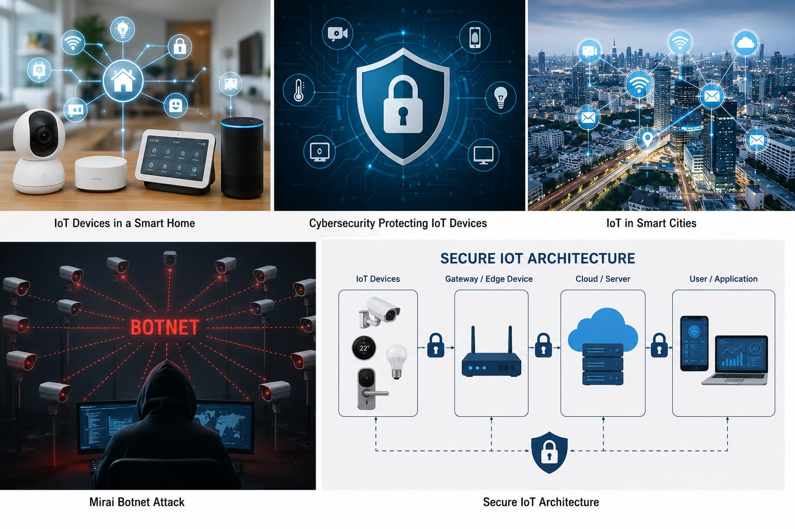Figure no 2 :- Security challenges and best practices.

Solutions
Organizations should implement strong passwords, multi-factor authentication, end-to-end encryption, regular firmware updates, secure network segmentation, continuous monitoring, AI-based threat detection, and employee awareness programs. Manufacturers should follow secure-by-design principles and provide long-term software support. Organization should implement strong passwords, multi-factor authentication, end-to-end encryption, regular firmware updates, secure network segmentation, continuous monitoring, AI-based threat detection, and employee awareness programs. Manufacturers should follow secure-by-design principles and provide long-term software support.

Benefits, Future and Conclusion
Strong IoT security protects privacy, prevents cyberattacks, increases customer trust, and supports reliable smart-city infrastructure. Future technologies such as Artificial Intelligence, blockchain, edge computing, Zero Trust architecture, and secure 5G networks will strengthen IoT ecosystems. In conclusion, IoT offers enormous opportunities, but its success depends on robust cybersecurity practices that protect users, organizations, and critical infrastructure. Strongs IoT security protects privacy, prevents cyberattacks, increases customer trust, and supports reliable smart-city infrastructure. Future technologies such as Artificial Intelligence, blockchain, edge computing, Zero Trust architecture, and secure 5G networks will strengthen IoT ecosystems. In conclusion, IoT offers enormous opportunities, but its success depends on robust cybersecurity practices that protect users, organizations, and critical infrastructure

